RC tutorial 004 - Alignment with vertical profile

=======================================

Revised 2022-11-14

* This tutorial's goal is to teach you more about RC alignments and the Alignment Manager.
* Assumed RailCOMPLETE skills: Previous lessons.
* Assumed railway skills: You know about railway geometry and how vertical profile is represented as Z(s) along that geometry.
* Time to spend here: 1 hour.
* Suggested reading: “2021-05-23_001 EN Introduction to RailCOMPLETE v2021.0”, which can be downloaded from our web pages.
* Notice to users with non-English versions of AutoCAD – see footnote[1].
* This tutorial was prepared using software release 2022.2.0.8 with Norwegian DNA version “NO-BN 2021.a (patch 1)”,” 2021-11-27T21:11:27+01:00;2021.a”.

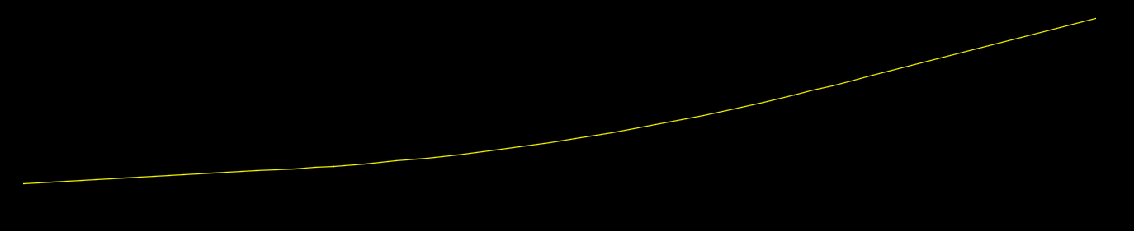

1. Start AutoCAD with RailCOMPLETE, then open the ‘National Tutorials’ folder and locate the DWG file named after this tutorial. You can either type **RC-OpenNationalTutorialsFolder** or you can locate the button below the RC logo in the upper left corner of your AutoCAD window. There are two DWG files – one is the start of the tutorial, the other shows the state you shall have reached at the end of the tutorial.

2. Start the Alignment Manager and select the alignment "T01". Keep it selected. You may keep the "Bind to Selection" box checked in the lower left corner of the Alignment Manager window, to synchronize modelspace alignment selections with the current Alignment Manager datagrid.

3. Activate the Alignment\Vertical tab. You will see a datagrid displaying the actual vertical profile details of your alignment.

4. Check "Extended View" to see more details, such as Length 3D (taking the effect of a varying elevation into account).

5. If you want to check out your alignment in 3D then select it and activate the 3D preview mode using command **RC-Show3dPreview**, then right-click and copy to drawing to keep it.  
Alternatively, right-click and select “RailCOMPLETE Export 3D” (**RC-Export3DusingCurrentSettings**).  
  
You may change the default settings using the Import/Export button in the ribbon and selecting command **RC-Export3D**.  
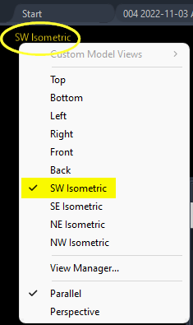  
  
Experiment with the graphics rendering type using AutoCAD command **_vscurrent**, or click in the upper left corner of your modelspace to access the AutoCAD rendering settings.  
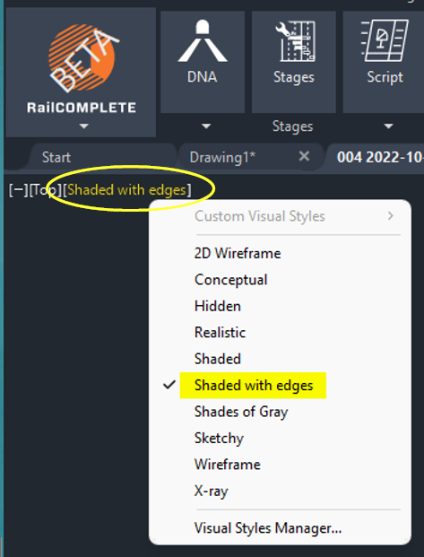

6. Revert to 2D Wireframe. Activate the **RC-ShowAlignmentProfile** tool and select the alignment to show vertical profile annotations. Copy them to the drawing using **RC-CopyAnnotationsToDrawing**.  
  
7. Note that the vertical profile has not been annotated at the geometry’s end point. Look at the alignment manager’s summary line above the data grid in the ‘Alignment/Vertical’ tab.   
  
Press F2 to show the AutoCAD log. Then run command **RC-AuditAlignments** and answer ‘Yes’ when asked to fix problems.   
  
  
RC detects that the PVI at Pos=470 falls outside of the alignment’s geometry, then computes a new PVI at the geometry’s end and stores the modified alignment.  
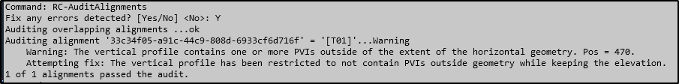  
  
Annotate the vertical profile again. Verify that the alignment’s end PVI is now annotated, and the datagrid’s last PVI has changed:  
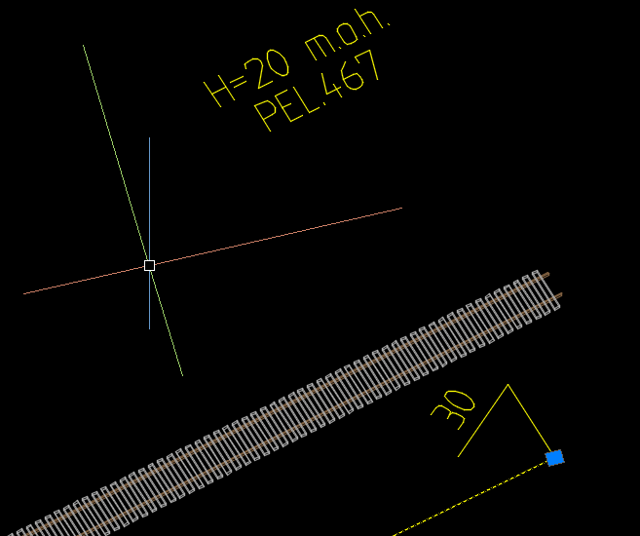  
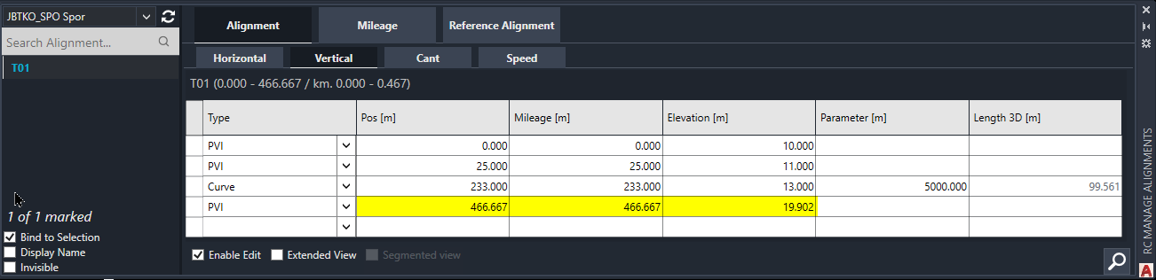

8. We will now make more changes to the alignment using the Alignment Manager’s vertical profile datagrid. Select the ‘Alignment’ tab and the ‘Vertical’ sub-tab and check "Enable Edit" in Alignment Manager to allow for modifications. Select the alignment T01.

9. Start by clicking the ‘PVI’ type at Pos=25, change the type to ‘Curve’. This introduces a circular rounding to the vertical profile around Pos=25. In the column ‘Parameter’, enter ‘50’ (which is a very sharp vertical curve, by the way – values from 5000 to 30000 are more common). In the column ‘Elevation’, enter ‘13’ instead of ’11’. With active 3D preview seen in ‘FRONT’ view, you should see this:  
The lower track (in 3D) is a 3D annotation (‘dead’ graphics) for the alignment we just had, whereas the uppermost is the 3D preview of the modified alignment.

10. Now reduce the smoothening radius at Pos=233 from 5000 to 500. Then add a new Point of Vertical Intersection (**PVI**) at Pos=350. Just enter ‘350’ in the Pos column of the empty bottom row. Once you hit ENTER, or you TABulate past the rightmost cell, the rows are sorted again in increasing Pos order. Set its type to ‘ParaCurve’ (parabolic vertical smoothening), its elevation to 8, and its parameter to 50. You should see this in FRONT view:  
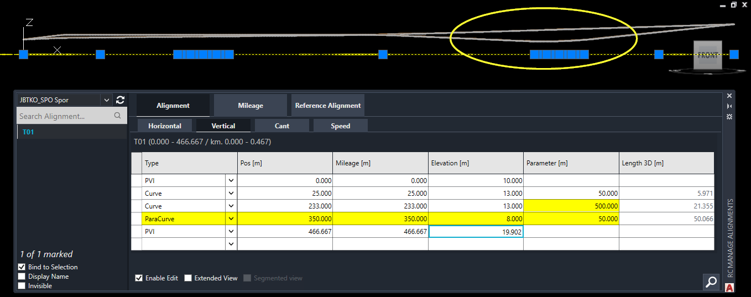

11. Delete the previous vertical profile annotation and produce it over again to annotate the new vertical profile (as seen in TOP view, 2D Wireframe rendering).  
  
At Norway’s Bane NOR, Vertical Curve Start (VCS) is annotated as "SE1" and Vertical Curve End (VCE) is annotated as "SE2".  
  
Vertical Parabola Start (VPS) is annotated “PE1” and Vertical parabola End (VPE) is annotated “PE2”.  
  
Crests are annotated as "HBP", and sags are annotated as "LBP" in the Bane NOR DNA.  
  
The PVI's Z-coordinate is shown as "m.o.h." in the Bane NOR annotations, meaning "m.a.s.l." (meters above sea level).  
  
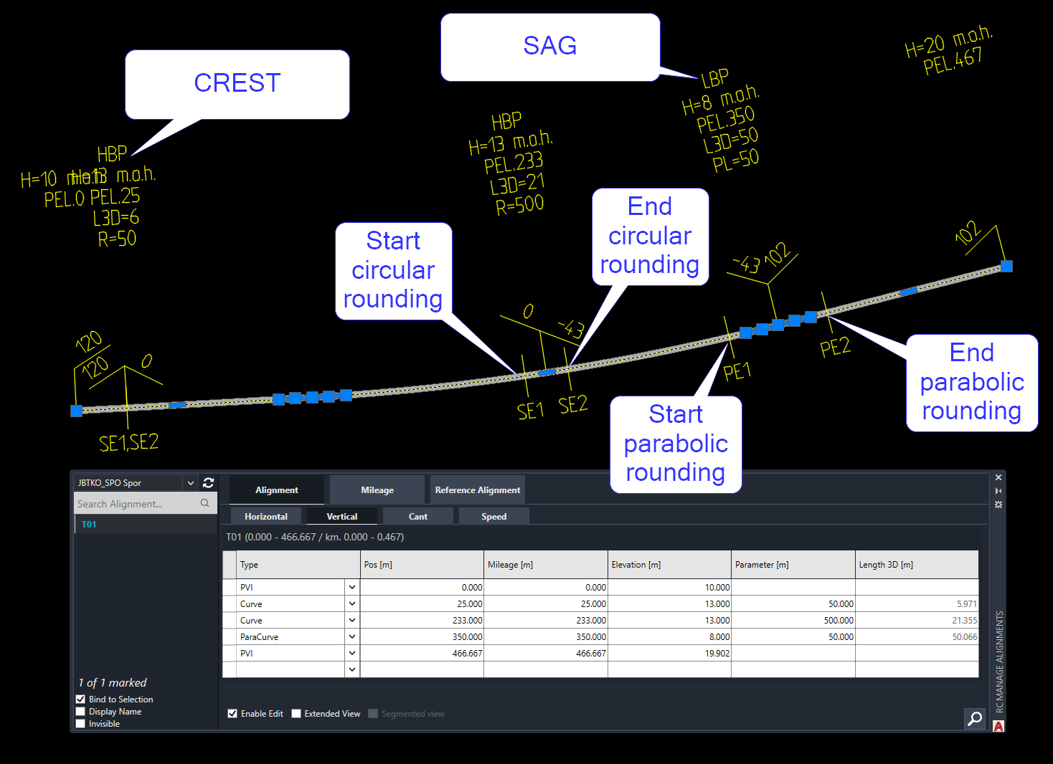

12. Revert to the Alignment\Vertical tab, check 'Extended View' (details) and mark the T01 alignment. The ‘Edit’ checkbox becomes unchecked. The Elevation column that you see here is the function 'Z(s)' where Z denotes an elevation above sea level, and s denotes the Position, i.e., the distance travelled along the alignment's geometry in the XY-plane. Note that the actual length (the 3D length) will be longer than the 2D length projected onto the geometry in the XY plane, due to the lengthening effect of ups and downs.

13. Vertical profile is expressed using Points of Vertical Intersection - PVI's. These are points belonging to the vertical trajectory Z(s), as long as Z(s) is a piecewise linear function. But as soon as you involve non-linear transition curves (circular arcs or other transitions) between straight segments of Z(s), then the PVI's are located where the extensions to these straight lines would have met. When the PVI is located above the smoothening curve we call it a 'Crest'. When the PVI is located below the smoothening curve we call it a 'Sag'.

14. In the **RC-Export3D** tool, select the ‘Alignments’ tab and check the ‘Alignment Axis’ checkbox.  
  
Export the alignment and then flip to FRONT view. The 3D expression of the alignment is no more consisting of sleepers and rails but is just a curve[2] in 3D space. This curve has the alignment’s geometry as its projection onto the XY plane, and the alignment’s vertical profile when expressed as Z(s) where s ranges from Pos=0 to Pos=2D_length.

18. To delete a row in the Alignment Manager, first mark the row by clicking in the small field to the left of the ‘Type’ column and press ‘Delete’ to remove the entire row. You can undo a bad deletion using Ctrl+Z from Modelspace.  
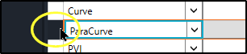

19. Note that AutoCAD hides text elements from time to time if you are not in the ‘2D Wireframe’ rendering mode.

20. Experiment with **RC-CreateAlignment**. By default, you are asked to draw the polyline yourself, which was the theme of preceding tutorials. But instead clicking the down arrow, you can select to create the alignment from an existing Polyline, or offset it from an existing RC alignment, or replace an existing RC alignment with a new one. The latter option will not modify the alignment’s geometry or profiles in any way, but it allows you to change the alignment’s ‘RcType’ property, the type of RC object, without altering the objects’ Globally Unique ID (GUID).  
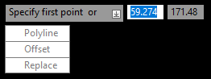

21. Experiment with Copy/Paste of vertical profile data between different alignments. You can copy a numerical value from a single cell in the source alignment's vertical datagrid, or you may copy multiple cells in one operation. Just note that you must mark an identical cell area (and check 'Enable Edit') in the target alignment datagrid, otherwise your paste operation will fail.

22. Experiment with Copy/Paste between an alignment datagrid and an Excel spreadsheet. You might experience comma/period conversion troubles, this will be due to differences between 'culture' (language / character sets) between your CAD system and your operating system.

23. Note that your vertical profile might start and end somewhere inside the extent of the geometry, i.e., not all the geometry would have a well-defined Z-coordinate. In such cases, you would experience 'missing profile data' (missing Z-coordinate) troubles in many built-in Lua formulas and in 3D rendering situations.   
Use the settings in RC-Export3D/Alignments to control how missing data should be treated.  
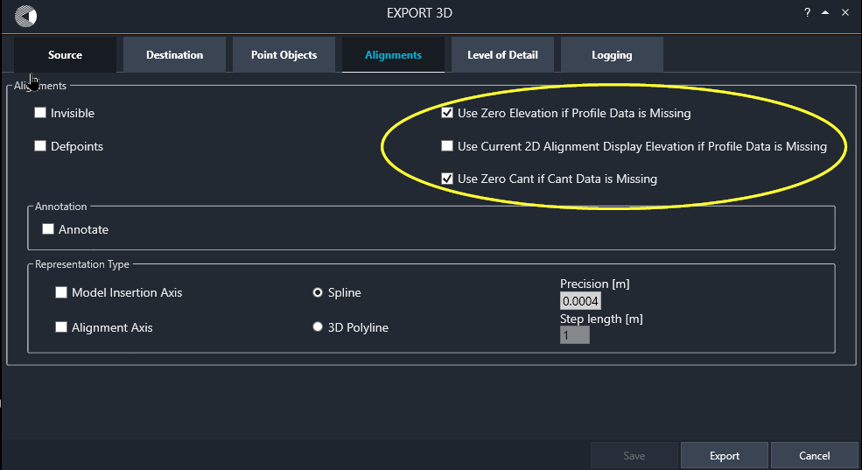

Please check our website www.railcomplete.com for updates.

Corrections and suggestions are welcome to support@railcomplete.com.

Thank you for using RC Tutorials!

1. Your AutoCAD session has probably been started from a Windows shortcut of the type:  
   “C:\Program Files\Autodesk\AutoCAD 2022\acad.exe” /product ACAD /language “fr-FR”, where “fr-FR” means “French language, France’s version”, or similar, or no language specified (English is the native language for AutoCAD). Native AutoCAD commands may have different names in your language pack, other than the COPY, COPYBASE, FIND etc that you see in our tutorial texts. In order to instruct AutoCAD to accept the native English command name, precede the native (English) command name by an underscore character, ‘_’. For instance: ‘_FIND’ will start AutoCAD’s native ‘FIND’ command even if you are using AutoCAD with the French language pack, where the command in French is called ‘RECHERCHER’.If a command needs an argument ‘ON’, and the French menu says ‘Allumer’, then you can enter ‘_ON’ to instruct AutoCAD to use the option’s native name. Furthermore, the English AutoCAD object selection prompt (command _SELECT) accepts many keyboard shortcuts such as A = (add) add to selection set, R = (remove) remove from selection set and AL = (all) all objects (and many more). These shortcuts are named differently in other language packs. In French they are for instance A=ajouter, S=supprimer, TO=tout. Consult AutoCAD Help in your native language.
2. The curve type can be set as ‘Spline’ (smoothened) or as ‘3D Polyline’. Use the ‘3D Polyline’ option when you want to produce a set of survey points along a jagged 3D polyline. The step length defines the distance between neighboring 3D vertices. The exported 3D is a block. Explode the block to access the 3D Polyline.